[**2. Microservices with API gateway outputs**](blob:https://github.com/d2147b96-8fad-4898-906b-0af4677d8411)

**Creating Microservices for account and loan**

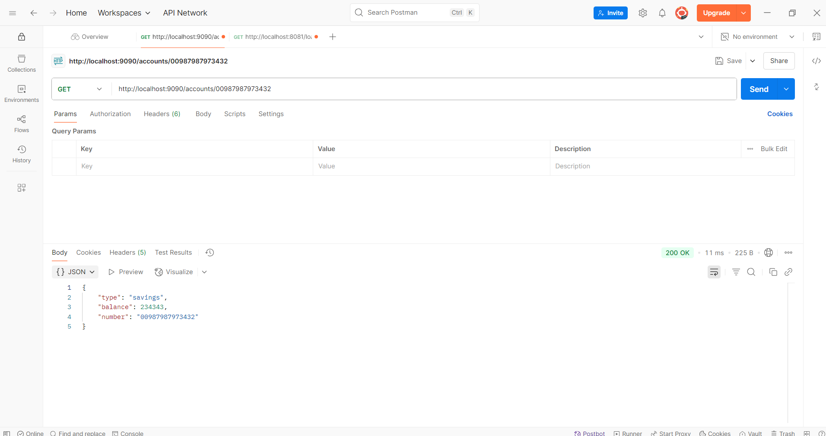

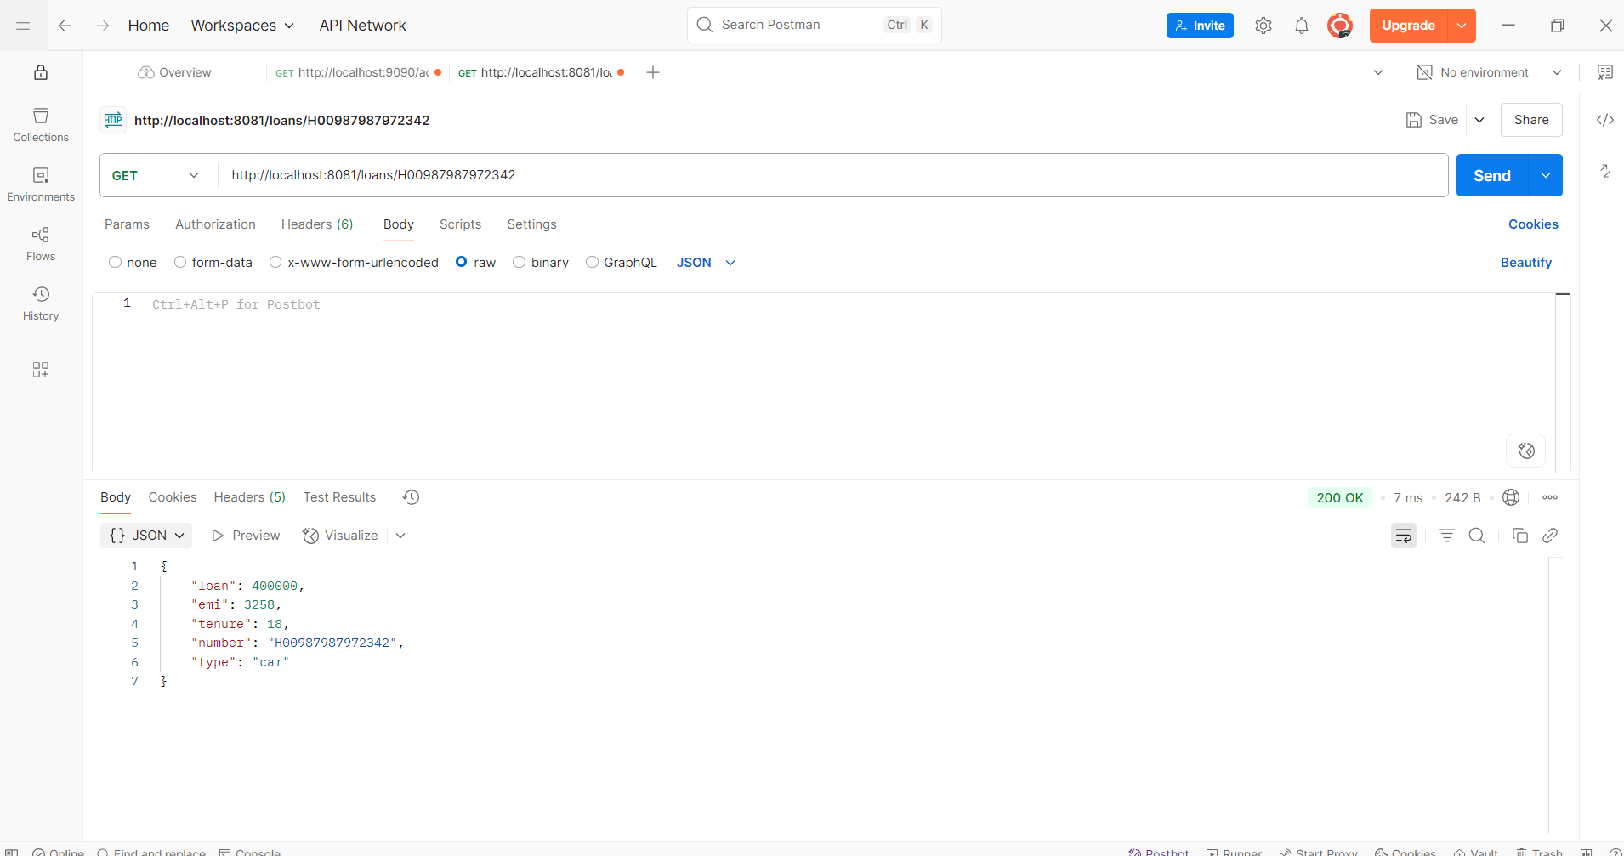

**Create Eureka Discovery Server and register**

